Министерство образования и науки Российской Федерации

Федеральное государственное бюджетное образовательное учреждение

высшего профессионального образования

Тамбовский государственный технический университет

Кафедра

Отчёт по лабораторной работе №3

по дисциплине «Вычислительная математика»

Вариант 3

Выполнил студент гр.

.

Проверил:.

Тамбов 20

**Постановка задачи:**

Произвести численное интегрирование системы дифференциального уравнения $y^{'}=x+\cos{\frac{y}{√10}}$ методом Рунге-Кутта, при y0(0.6)=0.8, x[0.6;1.6]

1. Блок схема метода:

a

x=x+h

k4=h*f(x+h,y+k3)

k3=h*f(x+h/2,y+k2/2)

k2=h*f(x+h/2,y+k1/2)

k1=h*f(x,y)

1 i=1

x=a

Ввод *y,h,a,f(x,y)*

начало

y=y+(k1+2*k2+2*k3+k4)/6

a

1

конец

Вывод x, y

1. Результаты:

h=0.1

x0 = 0.600000, y0 = 0.800000

x1 = 0.700000, y1 = 0.961377

x2 = 0.800000, y2 = 1.130955

x3 = 0.900000, y3 = 1.308612

x4 = 1.000000, y4 = 1.493958

x5 = 1.100000, y5 = 1.686582

x6 = 1.200000, y6 = 1.886053

x7 = 1.300000, y7 = 2.091921

x8 = 1.400000, y8 = 2.303731

x9 = 1.500000, y9 = 2.521023

x10 = 1.600000, y10 = 2.743340

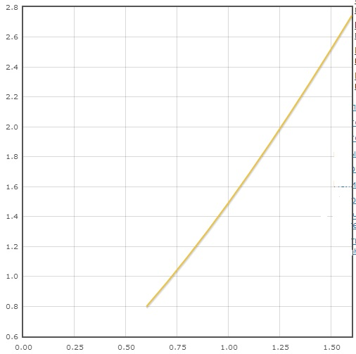

h=0.05

x0 = 0.600000, y0 = 0.800000

x1 = 0.650000, y1 = 0.879552

x2 = 0.700000, y2 = 0.961199

x3 = 0.750000, y3 = 1.044955

x4 = 0.800000, y4 = 1.130776

x5 = 0.850000, y5 = 1.218616

x6 = 0.900000, y6 = 1.308428

x7 = 0.950000, y7 = 1.400163

x8 = 1.000000, y8 = 1.493770

x9 = 1.050000, y9 = 1.589197

x10 = 1.100000, y10 = 1.686390

x11 = 1.150000, y11 = 1.785295

x12 = 1.200000, y12 = 1.885856

x13 = 1.250000, y13 = 1.988017

x14 = 1.300000, y14 = 2.091721

x15 = 1.350000, y15 = 2.196910

x16 = 1.400000, y16 = 2.303527

x17 = 1.450000, y17 = 2.411515

x18 = 1.500000, y18 = 2.520816

x19 = 1.550000, y19 = 2.631373

x20 = 1.600000, y20 = 2.743131

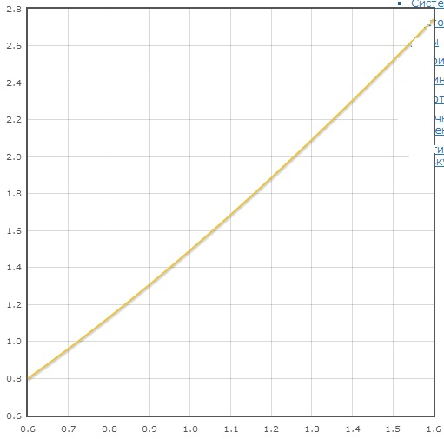

h=0.01

x0 = 0.600000, y0 = 0.800000

x1 = 0.610000, y1 = 0.815728

x2 = 0.620000, y2 = 0.831540

x3 = 0.630000, y3 = 0.847440

x4 = 0.640000, y4 = 0.863426

x5 = 0.650000, y5 = 0.879499

x6 = 0.660000, y6 = 0.895658

x7 = 0.670000, y7 = 0.911902

x8 = 0.680000, y8 = 0.928232

x9 = 0.690000, y9 = 0.944646

x10 = 0.700000, y10 = 0.961146

x11 = 0.710000, y11 = 0.977730

x12 = 0.720000, y12 = 0.994397

x13 = 0.730000, y13 = 1.011149

x14 = 0.740000, y14 = 1.027984

x15 = 0.750000, y15 = 1.044901

x16 = 0.760000, y16 = 1.061902

x17 = 0.770000, y17 = 1.078984

x18 = 0.780000, y18 = 1.096149

x19 = 0.790000, y19 = 1.113394

x20 = 0.800000, y20 = 1.130722

x21 = 0.810000, y21 = 1.148129

x22 = 0.820000, y22 = 1.165618

x23 = 0.830000, y23 = 1.183186

x24 = 0.840000, y24 = 1.200834

x25 = 0.850000, y25 = 1.218561

x26 = 0.860000, y26 = 1.236367

x27 = 0.870000, y27 = 1.254252

x28 = 0.880000, y28 = 1.272214

x29 = 0.890000, y29 = 1.290255

x30 = 0.900000, y30 = 1.308372

x31 = 0.910000, y31 = 1.326567

x32 = 0.920000, y32 = 1.344838

x33 = 0.930000, y33 = 1.363185

x34 = 0.940000, y34 = 1.381608

x35 = 0.950000, y35 = 1.400107

x36 = 0.960000, y36 = 1.418680

x37 = 0.970000, y37 = 1.437327

x38 = 0.980000, y38 = 1.456049

x39 = 0.990000, y39 = 1.474844

x40 = 1.000000, y40 = 1.493713

x41 = 1.010000, y41 = 1.512654

x42 = 1.020000, y42 = 1.531668

x43 = 1.030000, y43 = 1.550754

x44 = 1.040000, y44 = 1.569911

x45 = 1.050000, y45 = 1.589139

x46 = 1.060000, y46 = 1.608438

x47 = 1.070000, y47 = 1.627807

x48 = 1.080000, y48 = 1.647246

x49 = 1.090000, y49 = 1.666754

x50 = 1.100000, y50 = 1.686332

x51 = 1.110000, y51 = 1.705977

x52 = 1.120000, y52 = 1.725691

x53 = 1.130000, y53 = 1.745472

x54 = 1.140000, y54 = 1.765321

x55 = 1.150000, y55 = 1.785236

x56 = 1.160000, y56 = 1.805217

x57 = 1.170000, y57 = 1.825265

x58 = 1.180000, y58 = 1.845377

x59 = 1.190000, y59 = 1.865555

x60 = 1.200000, y60 = 1.885797

x61 = 1.210000, y61 = 1.906102

x62 = 1.220000, y62 = 1.926472

x63 = 1.230000, y63 = 1.946904

x64 = 1.240000, y64 = 1.967400

x65 = 1.250000, y65 = 1.987957

x66 = 1.260000, y66 = 2.008576

x67 = 1.270000, y67 = 2.029256

x68 = 1.280000, y68 = 2.049997

x69 = 1.290000, y69 = 2.070799

x70 = 1.300000, y70 = 2.091660

x71 = 1.310000, y71 = 2.112581

x72 = 1.320000, y72 = 2.133560

x73 = 1.330000, y73 = 2.154599

x74 = 1.340000, y74 = 2.175695

x75 = 1.350000, y75 = 2.196849

x76 = 1.360000, y76 = 2.218059

x77 = 1.370000, y77 = 2.239327

x78 = 1.380000, y78 = 2.260651

x79 = 1.390000, y79 = 2.282030

x80 = 1.400000, y80 = 2.303465

x81 = 1.410000, y81 = 2.324955

x82 = 1.420000, y82 = 2.346499

x83 = 1.430000, y83 = 2.368097

x84 = 1.440000, y84 = 2.389748

x85 = 1.450000, y85 = 2.411452

x86 = 1.460000, y86 = 2.433209

x87 = 1.470000, y87 = 2.455018

x88 = 1.480000, y88 = 2.476879

x89 = 1.490000, y89 = 2.498790

x90 = 1.500000, y90 = 2.520753

x91 = 1.510000, y91 = 2.542765

x92 = 1.520000, y92 = 2.564828

x93 = 1.530000, y93 = 2.586940

x94 = 1.540000, y94 = 2.609100

x95 = 1.550000, y95 = 2.631310

x96 = 1.560000, y96 = 2.653567

x97 = 1.570000, y97 = 2.675872

x98 = 1.580000, y98 = 2.698224

x99 = 1.590000, y99 = 2.720622

x100 = 1.600000, y100 = 2.743067

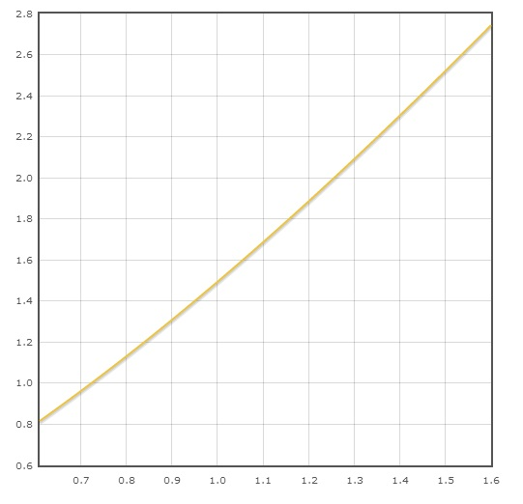

1. Листинг программы:

#include <stdio.h>

#include <math.h>

double q(double x, double y)

{

return x+cos(y/sqrt(10));

}

int main()

{ FILE *f=fopen("input.txt","w");

double x,y=0.8,h,k1,k2,k3,k4,a,b;

scanf("%lf %lf %lf",&h,&a, &b);

x=a;

printf("%lf %lf\n",x,y);

for(int i=1; i<(b-a)/h; i++)

{

k1=h*q(x,y);

k2=h*q(x+h/2,y+k1/2);

k3=h*q(x+h/2,y+k2/2);

k4=h*q(x+h,y+k4);

x=x+h; y=y+(k1+2*k2+2*k3+k4)/6;

printf("%lf %lf\n", x, y);

}

return 0;

}